MIGRANT RIGHTS CENTRE IRELAND ANNUAL REPORT
2013

Reflection from Bobby
IMMIGRANTS ARE US.
Hardly a week passes without reports of migrants drowning or being rescued in the Mediterranean and in other seas around the world. Many of these reports seem to focus the blame on migrants for risking their lives trekking across deserts, using rickety boats on the high seas and hiring traffickers to bring them to safety in the developed world where they perceive that a life with dignity and protection is possible. These people are anything but incompetent, good for nothings, worthless, scroungers, spineless or hopeless as sections of the media portray them.
Emigrants are the very opposite. They are brave people full of hope, a hope that energises them to leave home just like Irish and European peoples in previous centuries who braved the wide Atlantic in search of a better life. In the past, Irish and European emigrants left because there was no hope at home. The poverty of violence, dysfunctional institutions, inequality and common violence that make life unsafe propelled them to seek political, economic, social and religious freedom.
Affluent nations and trading areas in the developed world treat this wave of human movement as an irritation. They soothe their consciences in the fact that they are participants in aid programs to the developing nations that these emigrants leave behind. The recent European election campaigns by some anti-immigrant platforms raised the xenophobic temperature by sending out negative messages about immigrants. Even Irish responses to recent research indicated that immigrants are “bad” for the economy. One wonders if these respondents were including their own emigrants that are resident in the United States, Canada, in EU member states, Australia and elsewhere.
Common everyday violence creates atmospheres in which people, especially women and children do not feel safe. This stunts economic development prevents investment and the creation of opportunity that would offer populations a choice of staying at home or risking desert and sea crossings in the hands of traffickers.
Immigrants make sacrifices in contributing to the economies they work in with little protections particularly, coping with racism and marginalisation. However, they make greater sacrifices by their remittances that have long since surpassed international government aid contributions. Yet, in many developed economies they are called “scroungers” (Daily Express, 14/5/14). Sadly, mainstream political parties compete with anti-immigrant parties using anti-immigrant slogans leading to an erosion of trust, integration and the increase of xenophobia and racism.
Emigration is the human heart on a journey of hope. MRCI sets out to match that hope in the eyes of immigrants coming through its door in a spirit of welcome. In doing so MRCI hopes that similar agencies in countries where Irish emigrants arrive will be treated with similar courtesy and understanding. MRCI, in responding to the needs of emigrants, to be authentic, has to be asking what is causing their having to leave home.
DON’T BLAME IMMIGRANTS. BLAME THE LEADERS OF THE STATES THEY HAVE TO LEAVE.

Foreword
2013 was a very busy year for MRCI. We had some significant achievements and became the 2013 SOLIDAR Silver Rose award winners, recognising our social justice work across Europe. Some very important policy and legal advances were also achieved in 2013. These included criminalisation of forced labour in Irish law and the introduction of new policy guidelines to allow students who have secured Irish citizenship to reverse their fee status at third level. A political commitment to ratify the ILO Domestic Workers Convention came during the Irish Presidency and political and public support for earned regularisation grew.
MRCI’s casework and legal work was consistent throughout the year, with increasing numbers of undocumented migrants and timed out students seeking assistance. An application for priority hearing in the Mohammad Younis’s case was made to the Supreme Court. New trends in trafficking were identified in the area of cannabis production and MRCI remains the lead organising in this area of work. Our communications work grew in strength and reach and we continued to work with the trade union movement to mainstream migrant rights into union activities, policy, structures and practice. In particular we developed a partnership agreement with SIPTU to advance the concerns of domestic workers.
Our high level of participation and engagement with migrants continued in 2013. The recognition of MRCI’s model of community work is an accomplishment we are proud of. Throughout the year we were frequently asked to participate in National, European and international events to present our community work model. Validity of the empowerment approaches to human rights and social justice is increasing internationally and MRCI is often cited as a good practice model.
MRCI continued our commitment to building a strong civil society nationally and globally and in a time of decreasing resources maintaining solidarity at all levels is critical. We are members of the Community Workers Cooperative, the Community Platform, European Network Against Racism Ireland, European Anti-Poverty Network Ireland, and the Platform for the International Cooperation on Undocumented Migrants (PICUM). As 2013 was such a great year for MRCI with many long term campaigns coming to fruition, it is important to acknowledge that this work would not be possibly without the dedication, passion and commitment of the MRCI team, board, leaders and members of our action groups and campaigns. They are the heart and force behind MRCI.
Edel McGinley
Director

About MRCI
Our aim is to advance the rights of all migrant workers and their families
MRCI’s social justice and advocacy efforts are firmly rooted in community work theory and practice; theory informed by a critical analysis of the situation facing immigrants in Ireland, and practice underpinned by community work’s core values of participation, social justice, equality and anti-discrimination, empowerment and collective action for change.

Our belief is that lives can be improved when individuals act collectively

Our vision is for an open and inclusive Ireland where migrant workers and their families participate fully and equally

Participation - The basic right of migrants to participate in decisions and structures that affect their lives. We strive to create opportunities and spaces for migrants to participate in the organisation and at a broader community and societal level.
Empowerment - Individuals and migrant communities are empowered to address the unequal distribution of power, supporting individuals to link their lived experiences with an analysis of power and structural inequality and encouraging a move from individual experience to collective concern.

Collective Action - Once migrants have identified issues that impact on their lives and have begun to build an analysis of these, the next step is identifying actions to address these problems.

Drop in Centre

MRCI operates a drop in centre that opens to the public Monday to Wednesday; people come from all over the country to seek advice and information. The office is always busy with people coming and going. The Drop in centre is an important part of MRCI’s work and often our first point of contact with our migrant activists.
“MRCI are very helpful; fighting for the rights of Migrants isn't an easy job. It takes love, courage, patience and mercy. Continue fighting for the Undocumented, we are many”
Resource Centre user

MRCI provides information and advice in the following areas:
- Employment permits
- General immigration and residency matters
- Workplace rights
- Trafficking for forced labour
“MRCI has been very helpful to me. I am really happy and satisfied with [the] information and help I got from MRCI”
Resource Centre user

- Undocumented migrants

Interesting Fact: The youngest person we assisted was just a few months old, the eldest was 79.

Interesting Fact: In 2013, 332 people came to us to try to regularise their legal status. Justice for the Undocumented is lobbying the Government for a straightforward, pragmatic and fair way for undocumented workers, families and children in Ireland to become documented.

Interesting Fact: We assisted people from 103 different countries last year. The top ten were the Philippines, Mauritius, Brazil, China, Pakistan, Bangladesh, Nigeria, India, Ukraine, and Moldova.

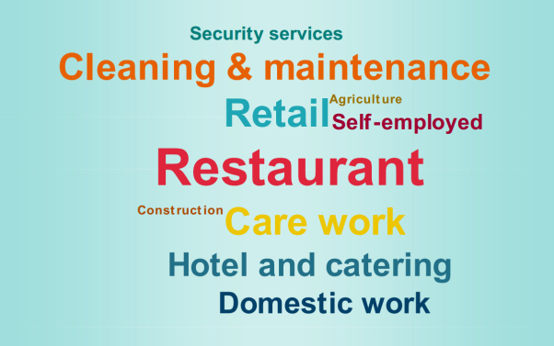
Most people who came through our Drop in Centre in 2013 worked in the following sectors……

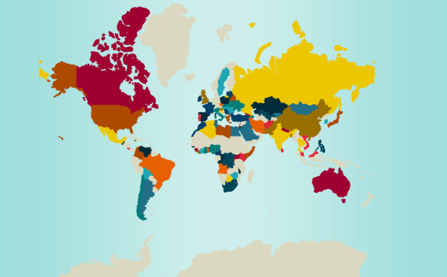
…….and they came from all over the world.

User survey 2013
One hundred people who used our service from January to November 2013 were surveyed. Participants were callers in the centre while waiting to be attended. We ensured diversity of nationality in selecting participants. Respondents came from Mauritius, Philippines, China, Nepal, Bangladesh, Philippines, Moldova, Ukraine, Pakistan, India, China, South Africa, Pakistan, Poland, Hon Kong, Turkey, Congo, Uganda, Brazil, Indonesian, Russia, Poland, Romania, Angola, Egypt, Botswana, South Korea, Vietnam, Nigeria, Zimbabwe and Malaysia.

User survey results

Migrants Forum
The Migrants Forum continues to be an important space for migrants to come together. The Forum is a place for migrant workers and their families to share their experiences, receive support and information, to share and develop an analysis of the issues facing migrant workers in Ireland, and identify solutions to these shared issues. The topics discussed reflect the trends and issues affecting migrants at that time. In 2013, we held four migrants’ forums, discussing topics form care to work permits and immigration reform. Every December 18th we celebrate International Migrants Day. This year clowns against borders came and delighted the huge crowd gathered in the Dublin’s mansion house. Leaders from MRCI’s groups and campaigns shared their reflections for the year and hopes for 2014.
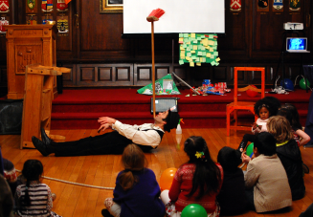

“The forum gives me the opportunity to be updated on laws and information that affects me and my family here in Ireland. It also informs me about what is going on in the lives of other migrant workers. In the future I think more migrant workers should involve in organising the forum, this will be very important.”
MRCI Migrants Forum attendee

Forced Labour and Trafficking
A campaign lasting almost two years came to a close in 2013 with the criminalization of forced labour in Ireland. This campaign was set up to respond to the need to tackle the chronic abuse and exploitation of workers that MRCI was witnessing. FLAG developed a briefing paper with the Irish Congress for Trade Unions (ICTU) on the problem and urgently-needed solutions. This paper was presented to policy makers and legislators. Solidarity meetings were held with the Trade Union Movement, the International Labour Organisation, Irish governmental officials and politicians to inform and lobby for the necessary changes.

Central to the success of this campaign were the dedicated members of the Forced Labour Action Group (FLAG). This group along with allies changed the law by securing an amendment to the Criminal Law (Human Trafficking) Act 2008. This now allows for forced labour to be prosecuted in Ireland. A big night to celebrate this achievement was held on 2nd October with the Dublin Lord Mayor Oisin Quinn hosting the event. To watch a short film entitled “The Journey to Criminalising Forced Labour” which documents the work put in to get forced labour criminalized click here- http://vimeo.com/76421752
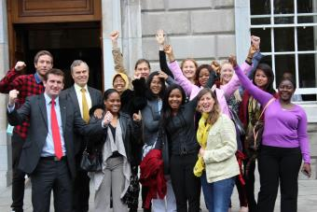

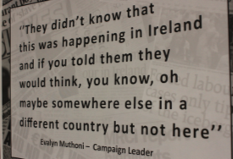

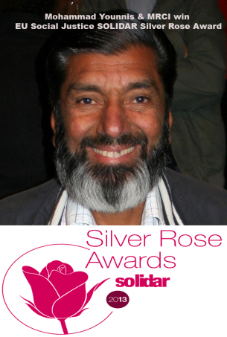
In October forced labour activist Mohammed Younis and MRCI were awarded the SOLIDAR Silver Rose Award 2013, recognising our social justice work across Europe.

Race Project
MRCI is a partner in the Race Project in collaboration with Anti-slavery international. The project examines trafficking for the purpose of criminal exploitation particularly in cannabis cultivation. In depth research was carried out for launch in 2014.

Fine Tunes Project
MRCI in cooperation with the International Trade Union Confederation (ITUC), Anti-Slavery international and Churches Commission for Migrants in Europe (CCME) a project on identification of forced labour and trafficking continued. This also aimed to strengthen identification in Ireland and embed responses to forced labour with National Employment Rights Authority (NERA) and the Trade Unions.

Research was carried out into the victims’ experiences of the Irish System and a policy paper setting out a new framework for identification produced. In February a joint Roundtable with NERA was held in the Department of Employment and Jobs. This was well attended by Labour Inspectors and an important discussion held on the identification of forced labour victims and the operation of inspections in workplaces. In March we held a joint seminar with Congress on identification and new form of trafficking. In December the research was launched at an International Conference, attended by GRETA and international speakers.

WORKPLACE RIGHTS
Reform on the Employments Permits Act is due in 2014. Towards the end of 2013 MRCI presented a detailed submission to the Department of Employment outlining our concerns. Meetings were held with key staff and a detailed response to MRCI’s policy amendments was issued. Clear indications were given for the introduction of an ongoing mechanism to respond to people who became undocumented through no fault of their own. This was a result of MRCI’s ‘bridging visa’ campaign, almost 8 years after it was initiated. This will now be put on a legislative footing and be known as a reactivation scheme.
The right to take a case irrespective of the person’s legal status is a core priority for MRCI. There will also be a provision to address the issues raised in the Amjad Hussien V Labour Court where the high court ruled that an undocumented migrant worker could not seek compensation for breaches of their employment rights due to their a legality of contact issues. This left undocumented workers in vulnerable position without recourse to redress. MRCI has been campaigning for a change in the law to bring these workers back under the protection of employment law; this issue will be addressed in the proposed reforms.
In the case of Amjad Hussien V Labour Court an application for priority hearing has been made to the Supreme Court to appeal the decision of the high court. Amnesty International has approached the MRCI’s and our legal team to apply to be amicus curiae to the case. Significant support and media work was done with Amnesty to raise awareness of the need for the amendment to bring all workers back under the protection of the employment courts
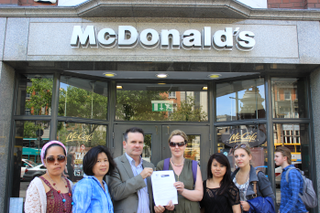
Work with the Trade union movement continued in 2013, particularity with SIPTU in relation to restaurant workers and domestic workers. As part of the Global Fast Food Alliances day of action, SIPTU and MRCI handed in a letter to McDonald’s.

Leadership Development
The participation of migrants continues a very important part of our work. Action and campaign groups continue to have this as their focus. Core migrant leaders took part in discussions on the future of migration in Ireland and on the future of MRCI. To enable our leaders to participation more fully in both MRCI’s work and externally taking up representational roles, in 2013 we are provided language supports, skill development and training on public speaking, communications.
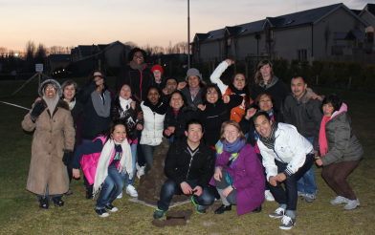
In March a leadership development residential weekend was held with some of our core leaders. The aim of the weekend was to provide support to leaders, to build confidence and critical analysis and develop the political and social consciousness of core leaders.

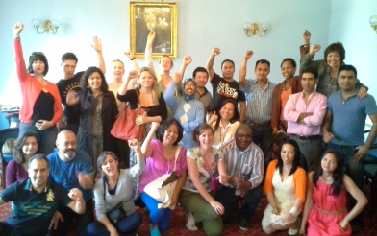
Leadership weekend in Blessington in March 2013

Core leaders meeting at the Teachers Club, Dublin July 2013

Justice for the Undocumented Campaign
The Justice for Undocumented (JFU) group has had a busy year. In 2013, the group reached over 700 members. The group is campaigning for the introduction of an Earned Regularisation Scheme, which would give undocumented people and their families living in Ireland a window of opportunity to come forward and earn their way to permanent residency status. The group held two mass meetings and 12 core group meetings. MRCI continues to organize ongoing induction meetings throughout the year - pioneering a new ways of engaging undocumented migrants in a collective agenda for change. This model creates the conditions to enable people to move from their individual experience in the Resource Centre to the collective space of the JFU group. New leaders have emerged in 2013 bringing renewed energy to the core group.
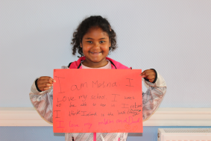
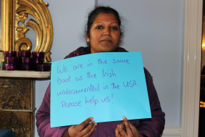
MRCI has come into contact with more children and families who are extremely vulnerable. We have seen the long term impact of living constantly under stress and fear on people’s health and wellbeing,. Many members continue encounter problems in accessing essential services, such as health and education and in working free form exploitation. Some JFU family members passed away in 2013 and they were unable to return home when loved ones passed away just like the Irish undocumented in the US. Cork City Council passed a motion in support of earned regularization in 2013 as the campaign enters a new phase of political support and engagement. Work continued to establish a Labour and Fine Gael working group to advance this issue.

Pathway to Citizenship in the United States of America and Ireland
In 2013, MRCI brought into focus the campaign to regularize the Irish undocumented in the US deliberately drawing parallels and highlighting the hypocrisy of the Irish government. The proposal submitted by MRCI to introduce a pathway to citizenship and currently with the Minister Shatter’s office, is very similar a bill being debated in the Sennate in the US. Both proposals are a form of earned regularisation, where people come forward pay and earn their right legal residence over a 5 year period. The introduction of a pathway to citizenship in the US will include the undocumented Irish who have made the US their home.

St Patrick’s Day
In 2013 JFU put a spotlight on the undocumented in the United Stated. On St Patrick’s day, the group held a transatlantic press conference linking up with the Irish International Immigrant Centre in Boston. An Irish undocumented woman spoke from Boston of her experiences and an undocumented woman spoke in Dublin of her experience of being undocumented in Ireland. This was a powerful moment in this campaign as they highlighted the similarities of their experiences and the parallels of immigration reform in the US and proposed responses for undocumented migrants in Ireland.

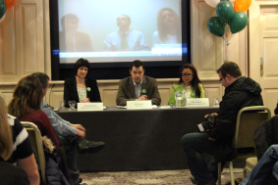

Journey for Justice
On Saturday 22nd June, the ‘Journey for Justice’ bus tour made its way in solidarity across Ireland. The bus tour was made up of members of the Justice for the Undocumented campaign and supporters who were calling for a pathway to Citizenship for undocumented migrants in Ireland, similar to the United States. The Western Region of Family Resource Centres hosted a civic reception in Galway City attended by the Galway city and county mayors, to welcome undocumented migrants living in Ireland. This was also attended by local senators and politicians. After the welcome in Galway, the bus made its way to the Cliffs of Moher for a photo call at this iconic location calling for justice for the undocumented. This was a journey of hope for 1000’s of undocumented migrants to living in Ireland.
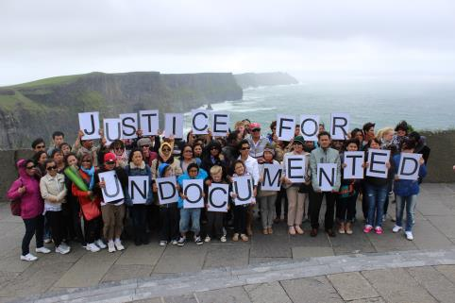

‘Document’
Members of the Justice for Undocumented group worked over the summer with Ireland’s National Theater - The Abbey, to develop and produce a play called ‘Document’. This took an honest, funny and heartbreaking look at the reality of life as undocumented migrant in Ireland. The group performed in the Abbey Theater as a work progress in August. They performed the final play at Larkin Hall, SIPTU in October. At both events there was a question and answers session.
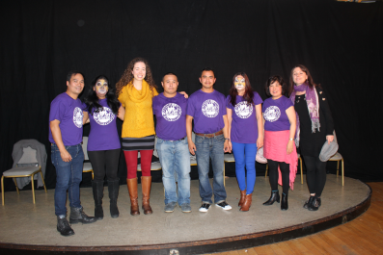

24 hours 4 hope
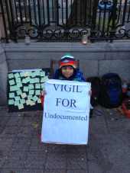
On December 11th 2013 the JFU campaign group and MRCI held a 24 Hour Vigil for Hope outside Dáil Éireann. The vigil was held from 9am on Wednesday December 11th until 9am on Thursday 12th. Every hour there was a game, song or activity to share experiences, get to know each other and keep spirits up. At 6pm a candlelit rally was held with over than 150 people attending. There was live music and speeches from group members and political allies. Many TDs came out of the Dáil and spoke out publically in support of the regularisation scheme. There was a fantastic atmosphere of solidarity, camaraderie and mutual support. People brought food and drinks and everything was shared collectively. There were many visitors throughout the day and night who came to stand in solidarity with the undocumented. It was a very emotional 24 hours as social media and public support grew. However it was the group standing together and sharing stories that was inspiring and a really positive experience for JFU.
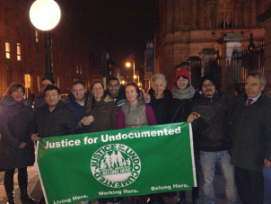
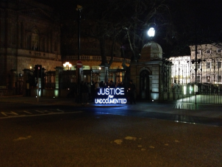
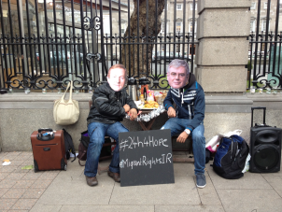

Domestic Workers Action Group (DWAG)
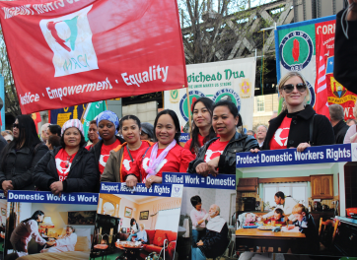
The Domestic Workers Action Group (DWAG) was set up in 2003 and celebrated their 10 year anniversary in 2013. The group is made up of migrant women working as childminders, nannies, housekeepers, and elder caregivers in Ireland. DWAG campaigns to improve rights and working conditions in this sector, with a central focus on ensuring domestic work is recognised as work.

May Day rally 2013
  - International Labour Organisation (ILO) Convention C.189 on Decent Work for Domestic Workers
During the Irish Presidency of the European Union, that the ratification of the International Labour Organisation (ILO) Convention C.189 on Decent Work for Domestic Workers was announced. DWAG joined the ITUC global campaign ‘12 by 12’ calling for governments to ratify C189, and urged Minister Richard Bruton to take action by bringing Irish laws in line with the international convention. The Minister stated in 2013 that he intends for Ireland to be one of the early ratifiers of the Convention.
  - Diplomatic Immunity
DWAG continued to call on the Department of Foreign Affairs to introduce mechanisms to protect the rights of domestic workers employed in diplomatic households, a number of high level meetings were held during the year and guidelines for embassy’s and diplomatic staff are expected soon. A protect outside the UEA embassy took place in May 2013 to highlight the lack of protections in this area.
  - Annual Gala
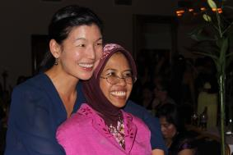
The Domestic Workers Annual Gala dinner took place on November 16th. Ai-Jen-Poo from the US Domestic Workers Alliance and Caring Across the Generations Campaign attended and was the key note speaker. Ai-Jen was identified in 2012 by Time Magazine as one of the most 100 influential people in the world. A film documenting and celebrating the ten years of DWAG was developed with the DWAG and showcased at the 10 year anniversary.

Trade Union Support
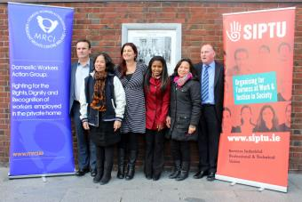
Work continued with SIPTU in the area of domestic work and as a strategic area of work for both organisations. DWAG appeared in Liberty magazine launching this partnership.

Migrant Care Workers
MRCI continued to deepen its analysis on the situation of migrant care workers providing home care provision. A roundtable was held in November in conjunction with SIPTU. Ai-Jen-Poo shared with us her experience of setting up the Caring Across Generations Campaign and what they are exploring in terms of the provision of quality care and quality jobs in this sector. She provided food for thought in the Irish context. This exchange and dialogue outlined new opportunities and challenges to advancing a care agenda that strengthens solidarity in the interests of quality standards, equality and decent work. Ongoing casework involving migrant care, domestic and home care workers continues.

Au Pairs

Au pairs continue to be an extremely exploited group of workers in Irish society whose rights are denied. We have continued to build our capacity to work with au pairs through establishing a working relationship with the Au pair Rights Association of Ireland (ARAI). A number of meetings were held between DWAG and ARAI during 2013. We have also been working with NERA to establish strategies to tackle the exploitation of au pairs; this work is on-going.

Migrant Education Access Campaign
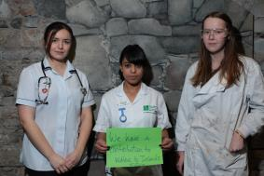
MRCI campaign to Third Level reverse fees for the children of non-EU migrants continued. The Migrant Education Access (MEA) campaign group continued to meet. A briefing paper on access to third level education for non-citizen children was developed and launched at a roundtable in

March. http://www.mrci.ie/wp-content/uploads/2012/09/MEA-Policy-Paper-2013.pdf This roundtable - “Minding the Gap Equal access to third level education for children of non-EU migrants” brought together policy makers, politicians, the Department of Education, the Office for the Promotion of Migrant Integration (OPMI) and others to discuss and explore practical solutions. An animated short called “Minding the Gap” http://www.mrci.ie/our-work/young-people-education/ created by the young members of MRCI’s MEA campaign highlighted the loss of their potential and the barriers they as people face in the education system in Ireland.

After 1.5 years of this campaign, in July the group achieved one of its two campaigns goals. A policy change was to be introduced to allow students who have secured Irish citizenship to reverse their fee status at third level. This was very closely negotiated and monitored with Department of Education and the Ministers political advisors. Citizenship applications for young people were processed at a faster pace and the Minister for Education committed to mapping and reviewing the current practices in Irish third level institutions in relation to the admission of young people from a migrant background.

A fantastic celebration was held in September to celebrate and draw the campaign to a close, the group made another wonderful film called “Not Bad for a Bunch of Immigrant Kids” which told the story of their campaign journey and what it mean t to them to be involved in a collective action for change. http://migrantrightscentre.tumblr.com/post/62066040085/not-bad-for-a-bunch-of-immigrant-kids-in-july .

Communications
We continue strive for excellence throughout all our work priorities including refining our communications and internal data management systems to enable more efficient working methods. In 2013, MRCI’s communications has gone from strength to strength. A key focus of 2013 was to grow MRCI’s presence on social media, in particular on Facebook and Twitter. Though our campaigns we have seen the growth and reach of social media and the impact this has on social media. MRCI’s engagement and communication with migrant workers also grew and this engagement saw MRCI participating in wider debates on economic justice, border control and management, environmental and developmental concerns. MRCI’s presence in the mainstream media continued to be high. We released 22 press releases and had over 100 engagements in the print media and on radio and TV.

EU & International Work
MRCI continued its work at the EU and International level, Edel McGinley continued to play an active role on the board of Platform for the International Cooperation on Undocumented Migrants (PICUM). MRCI in conjunction with Crosscare, NASC and Cultúr organised a national roundtable on the EU Multiannual framework and new Asylum Migration and Integration Fund. The Director General of Home Affairs Mr Manservisi, attended the workshop with over 30 Irish NGO’s to look at setting Ireland’s priorities under this fund. In January MRCI held a roundtable on EU migration policy under the Irish Presidency of the EU. We were involved in the UN High-Level Dialogue on International Migration and Development 2013 and in January we made a submission to the EU Commissioner Cecilia Malmström Home Affairs. Throughout 2013 we continued to be involved in a number of EU projects around Trafficking for Forced Labour and worked with Anti-slavery International, the International Trade Union Confederation (ITUC), and Churches Commission for Migrants in Europe (CCME).

ENAR Ireland & Racism
MRCI is a member of ENAR Ireland and throughout 2013, we continued to support the European Network Against Racism (ENAR) Ireland, especially its work in the area of racist incident recording and monitoring. A revamped reporting system iReport was developed. The launch of this is June was hugely successful and MRCI continues to report incidents coming in through the Resource Centre. iReport is a civil society reporting mechanism for people, communities and organisations who experience, witness or are informed of racist incidents and document incidents of a racist nature occurring nationwide. http://enarireland.org/ireport/

Organisational Development
In 2013 we had a number of team building exercises and team get-togethers. These spaces are important for us to develop our collective analysis on new trends and issues, they help us reflect on our work and generate new ideas and to ensure we are true to and achieving our vision and vision. We have two new additions to the MRCI Family, little Vitto and Ruairi were born. We also welcomed two new staff members in 2013; Adelita Montiero who covered Aoife Smith’s maternity leave on a part-time basis from July to December and Dearbhla Ryan who came on board as Development Worker in November.
Special thanks to the interns, volunteers and students from NUI Maynooth who contributed so much to the work of MRCI during 2013 including Dearbhla Ryan, Agnieszka Pikulicka, Beryl Delaney, Marco Natale, Ben Murray, Deirdre Jansen van Vuuren, Maria-Elen Bottigliero, Jenny Hayes, Juliet Kira, Ronan Forde, Jonathan Dowling, Erica Salvino, Rosalie Seward. A massive ongoing thanks to Lorelei Ocaya and Lenette Toledo who continued to volunteer on Reception throughout 2013.
At the end of 2013 sadly Siobhan O’Donoghue announced she was stepping down as Director after nearly 12 years at the helm.
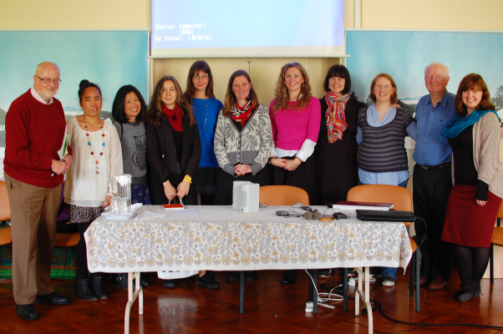In October the team visited Dalgan Park to do a presentation on our work at the Columban Missionary Society AGM.

Sustainability
We did a lot of strategic thinking in 2013 to develop future work with migrants at risk of poverty, social exclusion and exploitation. The possibility of closer collaboration with organizations that share similar values and focus on social justice issues has been a priority of this strategic vision. An important strand is the engagement of the trade union movement to explore and build new and innovative approaches to protecting migrant workers form exploitation. Understanding our core sustainability needs has also been an area of focus.

As part of their exit strategy, Atlantic Philanthropies invited the six migrant organisations it funds (MRCI, Immigrant Council of Ireland (ICI), Irish Refugee Council (IRC), The Integration Centre, NASC, Doras Lumni) to submit a single application for funding in March 2014. This resulted in MRCI and IRC working closely to explore deeper collaboration, including sharing a building and developing a joint drop in centre. MRCI board met 4 times in 2013 and its sustainability working group meets regularly to oversee the sustainability plan of MRCI.

